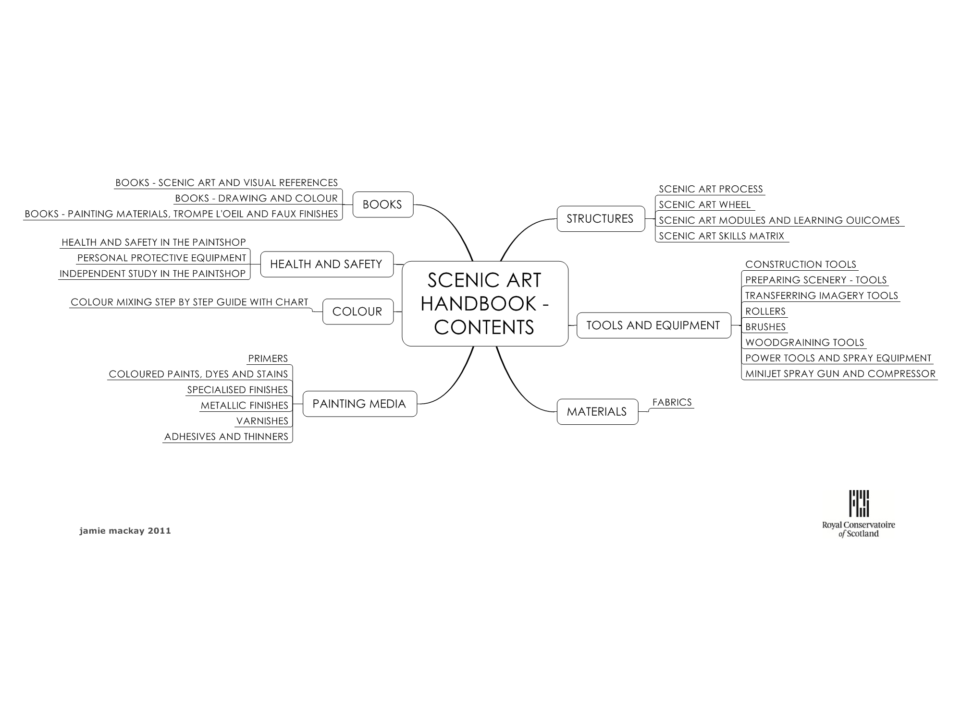
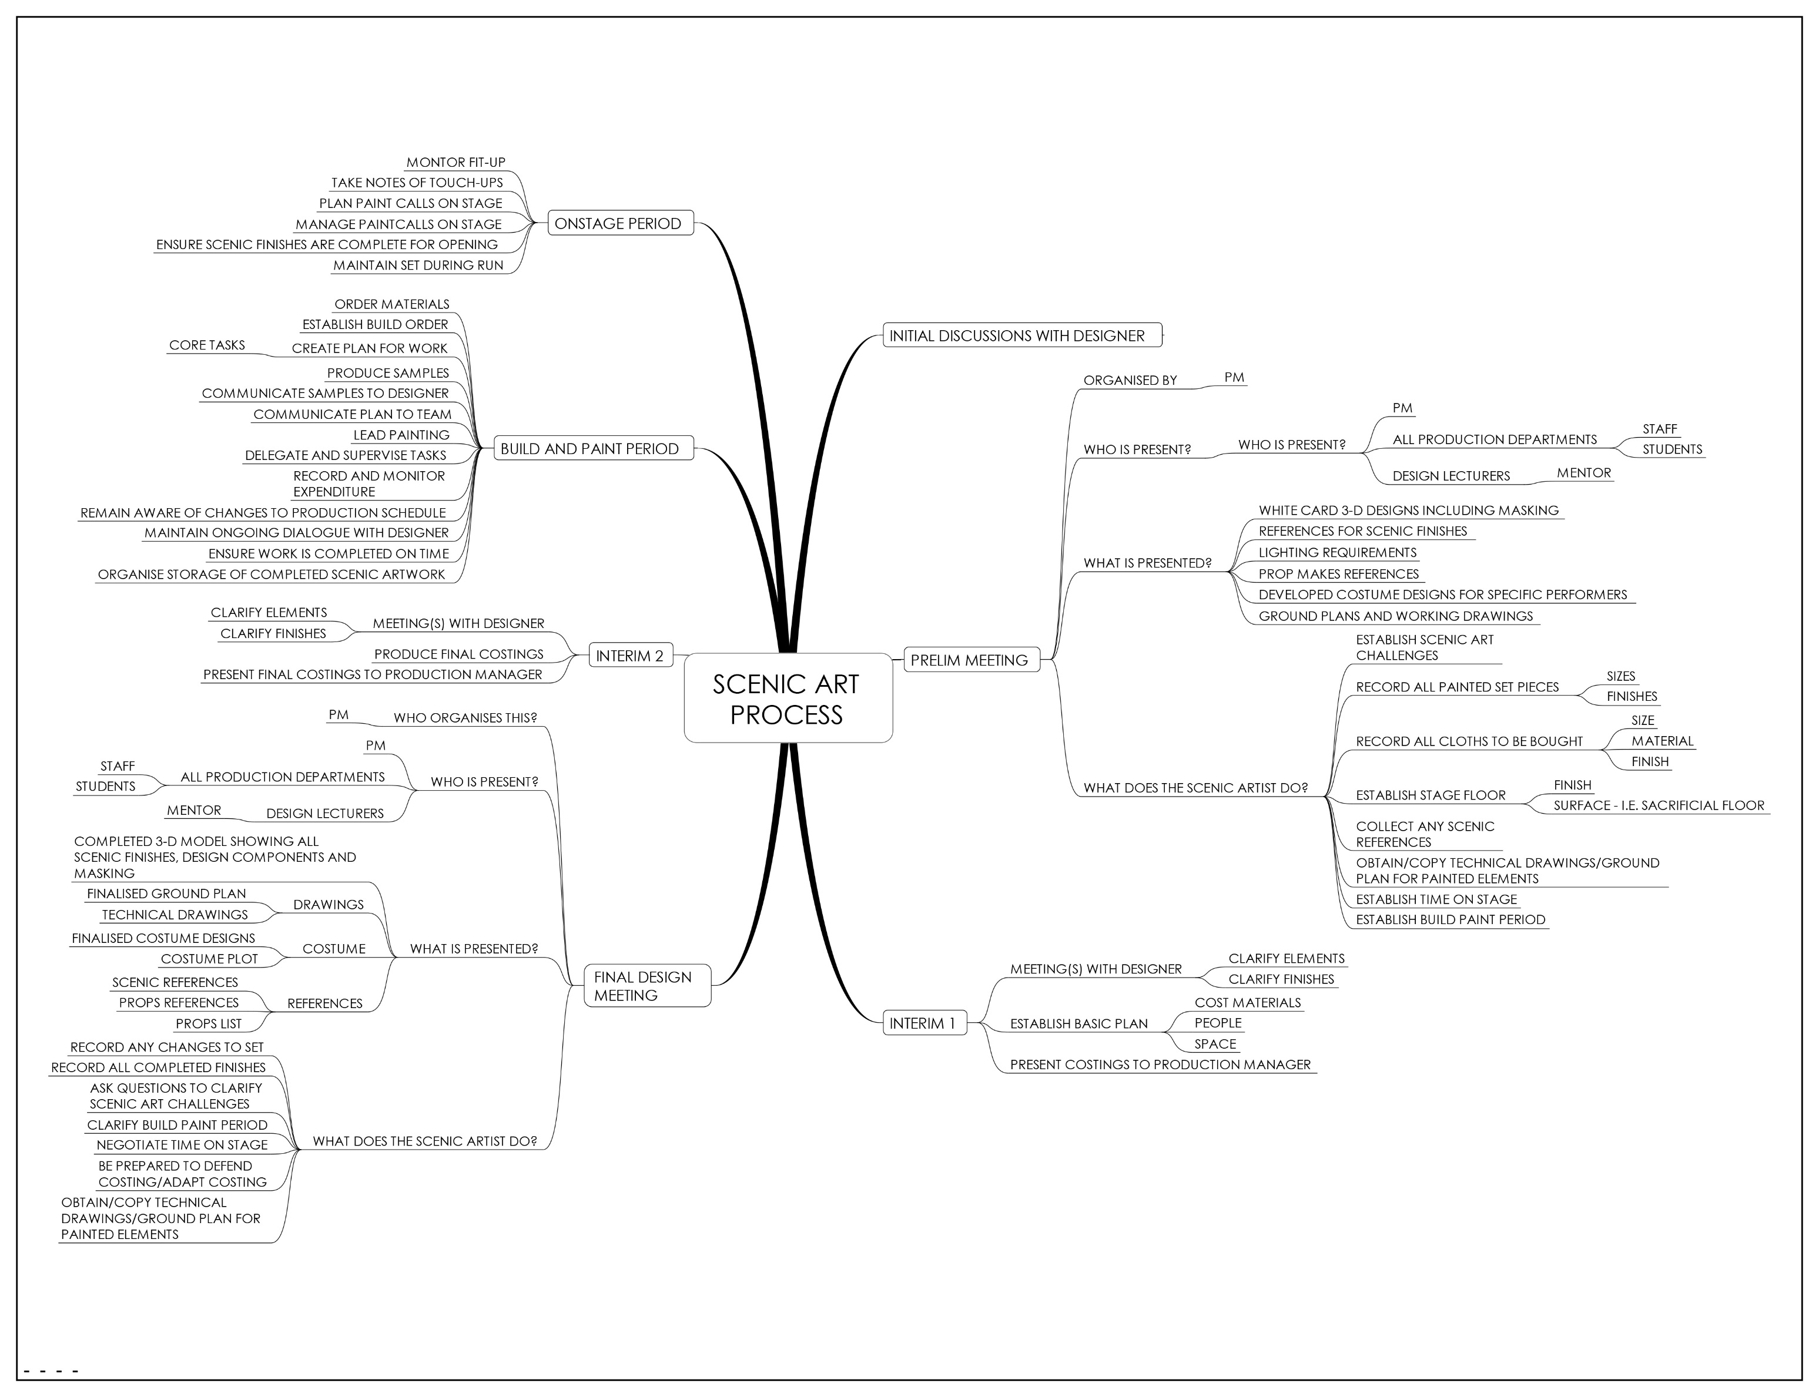
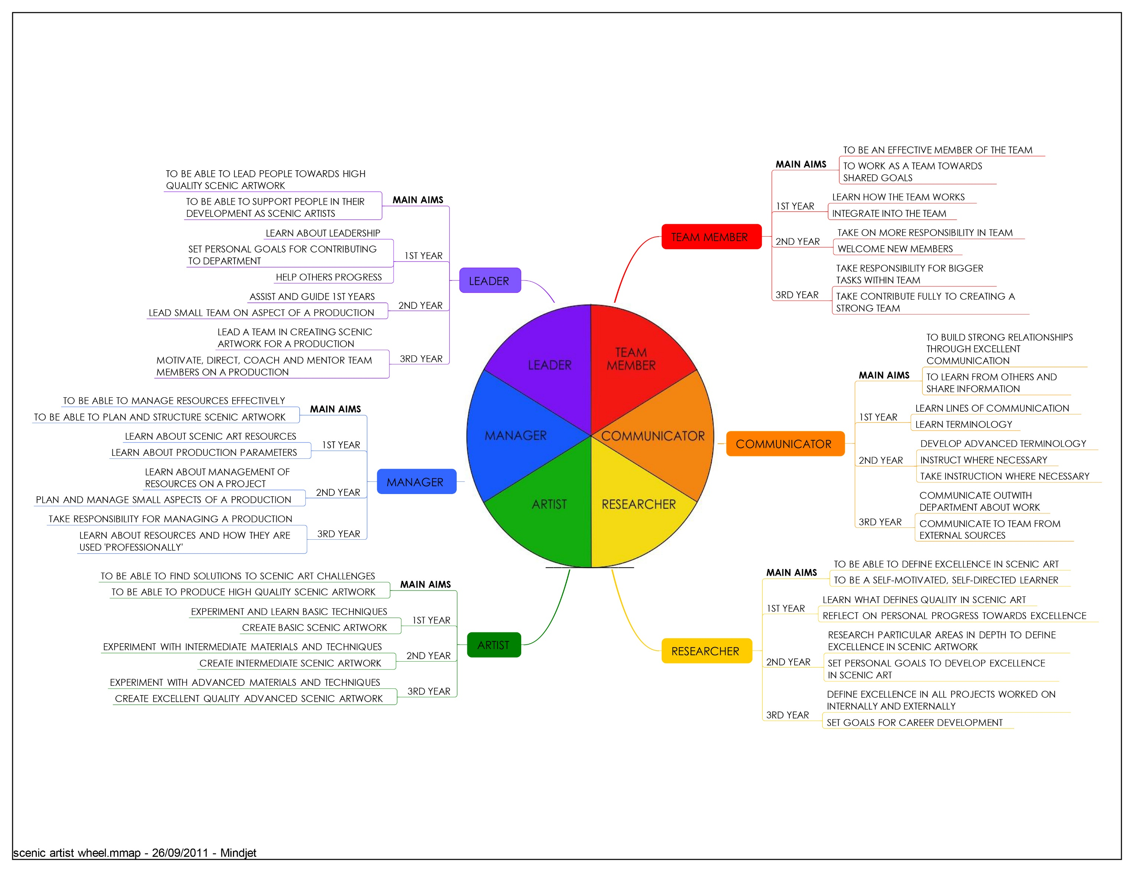
Learning Outcomes and Assessment modes retaining minor subject in 2nd year

YEAR OF STUDY | LEVEL 1 |  | LEVEL 2 (retaining minor subject option)
MODULE | PA&D1 – intro to the production process | PA1 – major workshop allocation 1 | *PA2 – major subject allocation 2 | PA3 – major subject allocation 3
TIME (Hrs) | 75 | 225 | 240 | 280
TIMEFRAME | T1 (2 week rotation) | T2 week 1-6, 8-9 | T1 week 1-6, 8-11 | T2 week 1-6, 8-15
Learning Outcome 1 | Evidence an understanding of the fundamental skills required to realise performance designs. | Apply foundation level skills required to realize performance designs in major subject in a safe and appropriate manner | With guidance apply intermediate level skills required to realise performance design | Apply intermediate level skills required to realise performance design.
Learning Outcome 2 | Evaluate the collaborative nature of the production process | Evidence a foundation level understanding of the role of the production artist in major subject | Work collaboratively as an effective member of a team in realising production designs | Evidence a foundation level understanding of workshop management in your major subject
Learning Outcome 3 | Evidence an understanding of the role of the scenic artist, prop maker, costume maker, scenic carpenter, designer, stage manager, technical stage manager and production electrician |  | Evidence an understanding of the duties and responsibilities of the production artist in the area of major subject | Document reflection on your learning and development as a production artist preparing for a senior production role in level 3
Learning Outcome 4 | Evidence a basic knowledge of working procedures and health and safety requirements for production |  | Document and evaluate research in specialist subject.
Assessment Mode 1 | Completion of written assessment and production arts skills assessments  (LO1, LO3, LO4) | Skills competency (LO1, LO2) 70% | Skills competency  (LO1, LO2, LO3) 80% | Skills competency 70%
Assessment Mode 2 | Design projects (LO2, LO3) | Personal project (LO1, LO2) 20% | Research in journal (LO4)  10% | Management written assignment  20%
Assessment Mode 3 | Written assessment of Production Technology and Management (LO3, LO4) | Reflective journal (LO2)10% | Reflective summary(LO3)  10% | Reflective Summary and Goals Statement 10%  - Reflective Summary 5%  - Goals Statement 5%
Assessment Mode 4 | Reflective journal (LO2, LO3, LO4)

Learning Outcomes and Assessment modes dropping minor subject in 2nd year

YEAR OF STUDY | LEVEL 1 |  | LEVEL 2 (dropping minor subject option)
MODULE | PA&D1 – intro to the production process | PA1 – major workshop allocation 1 | *PA2 a – major subject allocation 2 (extended version) | PA3 – major subject allocation 3
TIME (Hrs) | 75 | 225 | 336 | 280
TIMEFRAME | T1 (2 week rotation) | T2 week 1-6, 8-9 | T1 week 1-6, 8-15 | T2 week 1-6, 8-15
Learning Outcome 1 | Evidence an understanding of the fundamental skills required to realise performance designs. | Apply foundation level skills required to realize performance designs in major subject in a safe and appropriate manner | With guidance apply intermediate level skills required to realise performance design | Apply intermediate level skills required to realise performance design.
Learning Outcome 2 | Evaluate the collaborative nature of the production process | Evidence a foundation level understanding of the role of the production artist in major subject | Work collaboratively as an effective member of a team in realising production designs | Evidence a foundation level understanding of workshop management in your major subject
Learning Outcome 3 | Evidence an understanding of the role of the scenic artist, prop maker, costume maker, scenic carpenter, designer, stage manager, technical stage manager and production electrician |  | Evidence an understanding of the duties and responsibilities of the production artist in the area of major subject | Document reflection on your learning and development as a production artist preparing for a senior production role in level 3
Learning Outcome 4 | Evidence a basic knowledge of working procedures and health and safety requirements for production |  | Document and evaluate research in specialist subject.
Assessment Mode 1 | Completion of written assessment and production arts skills assessments  (LO1, LO3, LO4) | Skills competency (LO1, LO2) 70% | Present accurate resource projections for an identified piece of work appropriate to subject | Skills competency 70%
Assessment Mode 2 | Design projects (LO2, LO3) | Personal project (LO1, LO2) 20% | Skills competency (LO1, LO2, LO3)  70% | Management written assignment  20%
Assessment Mode 3 | Written assessment of Production Technology and Management (LO3, LO4) | Reflective journal (LO2)10% | Research in journal (LO4)  10% | Reflective Summary and Goals Statement 10%  - Reflective Summary 5%  - Goals Statement 5%
Assessment Mode 4 | Reflective journal (LO2, LO3, LO4) |  | Reflective summary(LO3)  10%

Learning Outcomes and Assessment - Level 3 (management module is elective)
Learning Outcomes and Assessment if scenic art is a minor subject
YEAR OF STUDY |  | LEVEL 1 | LEVEL 2
MODULE |  | PA&D2 – minor subject allocation 1 | PA&D4 – minor subject allocation 2
TIME (HOURS) |  | 160 | 88
TIMEFRAME |  | 5 weeks | 4 weeks
Learning Outcome 1 |  | With guidance apply foundation level skills in the realisation of production or performance designs/project work in minor subject | Autonomously apply foundation skills in a production/project context in minor subject
Learning Outcome 2 |  | Evidence a foundation level understanding of the role of the production artist or designer in minor subject | Work collaboratively as an effective member of a team in developing/realising production designs in your minor subject
Learning Outcome 3 |  |  | Evidence an understanding of the duties and responsibilities of the production artist or designer in the area of minor subject
Assessment Mode 1 |  | Skills Competency (LO1) 90%. | Skills Competency in minor subject (LO1, LO2) 90%
Assessment Mode 2 |  | Reflective summary and goals statement (LO2)10% | Reflective summary (LO3)  10%

YEAR OF STUDY | LEVEL 3
MODULE | PA4 – major subject allocation 4 | PACE1 20/30 – workshop management – CORE ELECTIVE
TIME (HOURS) | 450 | 170/280
TIMEFRAME | 14 weeks to be negotiated | 6-10 weeks to be negotiated
Learning Outcome 1 | Apply advanced level skills in the realisation of performance designs in your major subject | Apply advanced skills in leading the realisation of performance designs for a small-scale/large scale production
Learning Outcome 2 | Evidence a wide and detailed enquiry into your specialist subject and evaluate your own effectiveness and areas for development | Undertake management and leadership responsibilities associated with role of the production artist in the realisation of a small-scale/large scale production.
Learning Outcome 3 | Apply effective leadership, communication and interpersonal skills in a senior role | Document management process for a small-scale/large scale production
Learning Outcome 4 |  | Reflect on effective management and leadership for a small-scale/large scale production
Assessment Mode 1 | Skills Competency (LO1, LO3) 90%. | Observation of application of management skills (LO1, LO2)  60%.
Assessment Mode 2 | Reflective journal (LO2)10% | Documentation of management process (LO3) 30%
Assessment Mode 3 |  | Reflective journal (LO4)  10%

SCENIC ART SKILLS MATRIX
YEAR OF STUDY | LEVEL 1 |  | LEVEL 2 |  |  | LEVEL 3
MODULE | PA&D1 – Intro to the production process | PA1 – major workshop allocation 1 | *PA2 – major subject allocation 2 OR | *PA2a – major subject allocation 2 (extended version) | PA3 – major subject allocation 3 | PA4 – major subject allocation 4 | PACE1 20/30 – workshop management – CORE ELECTIVE
TIME (HOURS) | 75 | 225 | 240 | 336 | 280 | 450 | 170/280
TIMEFRAME | T1 (2 week rotation) | T2 week 1-6, 8-9 | T1 weeks 1-6, 8-11 | T1 week 1-6, 8-15 | T2 week 1-6, 8-15 | 14 weeks to be negotiated | 6 – 10 weeks to be negotiated
Learning Outcome | Evidence an understanding of fundamental skills | Apply foundation level skills | With guidance apply intermediate level skills |  | Apply intermediate level skills | Apply advance level skills | Apply advanced skills in leading
Preparing scenery | Preparing boards | Preparing built scenic elements, cloths, stage floors | Preparing cloths |  | Preparing unusual substrates | Preparing range of appropriate surfaces in a production context | Managing the appropriate preparation of a range of surfaces in a production context
Drawing | Scaling-up image using grid | Using pounce and stencil | Lining-out cartoon |  | Drawing geometry Pythagoras theorem and perspective | Applying range of appropriate drawing in a production context | Managing the appropriate drawing in a production context
Colour-mixing | Basic colour and colour mixing – colour wheel | Mixing layered colours to create variety of finishes | Mixing and applying layered colour in replicating scenery for a production |  | Mixing and applying colour in replicating an image | Applying range of appropriate colour mixing in a production context | Managing the application of a range of appropriate colour mixing in a production context
Painting 2-D | Replication of basic 2-D paint applications | Replication of aged 2-D surfaces – metal, concrete. Painting on stage floor | Accurately replicate faux finish for a production from a given design |  | Create convincing Trompe-L’oeil finishes | Applying range of appropriate 2-D finishes in a production context | Managing the application of a range of appropriate 2-D finishes in production context
Texture | Replication of basic textured surfaces | Replication of metal and rust textures | Replication of brick , wallpaper and ageing texture |  | Creation of texture sample book | Applying range of appropriate 3-  D texture finishes in a production context | Managing the application of a range  of appropriate 3-D texture finishes in a production context
Materials, tools and equipment | Basic brushes, rollers, paints,  Thinners and mixers. | Tools and materials for textures, creating metallic finishes, wood graining transferring images | Knowledge of cloths, spray-gun and compressor |  | Dyes, guns, primers | Applying range of appropriate tools, materials and equipment in a production context | Managing the application of range of appropriate tools, materials and equipment in a production context
Health and Safety | Introduction to Safe Systems of Work – Paintbridge, PPE, compressor, A-frame ladder | Risk assessments. COSHH, sump, flammable paints. | Safe Systems of Work –, spray-gun and compressor. Produce risk assessments for project |  | Risk assess work on a production | Monitor health and safety practice of Level 1 and 2 students | Manage all health and safety of department. Generate risk assessments for production. Deliver health and safety guidance for other students
Projects | 2-D paint application techniques, colour wheel, lettering, ageing | Personal project  e.g  Metallic finishes; repeat pattern; portrait | Research a chosen aspect of scenic art  Personal project  e.g  Patination; substrate prep and finish | Research a chosen aspect of scenic art.  Produce freelance costing | Analysis of management of a piece of work  Advanced substrate preparation, possible second income generation. | Advanced level projects that help develop skills and generate work for portfolio e.g.  Paint a 3-D prop, stained glass / FEV, geometric pattern, landscape, sky, perspective, portraiture

