

**Ice Effect on Perspex**

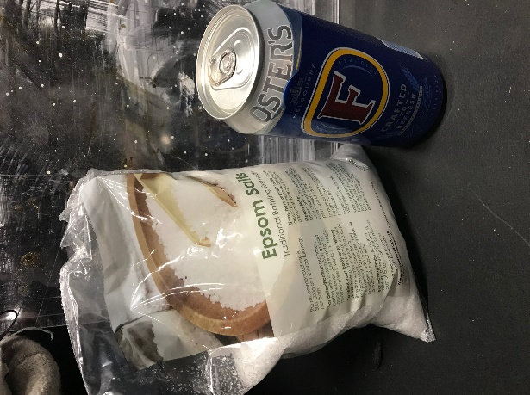 

1 cup of flat beer ( Fosters) to 4 tbsp Epsom salts.

(As shown in the video) add your salt to the beer and mix together, it will foam up even though it’s flat, once mixed let it rest for 10 minutes and mix it again before applying to your surface area. I kept mixing as I went along. If you use a clear bowl you can see if the salt has dissolved into the beer or not, you don’t want it all clumped at the bottom

Dabbing it on with a brush gives you an ice effect whereas using brush strokes it does a more frosted effect.

The mixture goes a long way. I used 4 cans of beer (8 cups) for an area of 5m x5m.

The original web page says fans are not our friend whilst doing this but I still put one on, on its lowest speed and at the far end of the room just to get the air circulating, this sped up the drying process massively and only took about an hour to dry rather than 12 hours without any cool air.

If like me and your using Perspex then your flipping it over so the beer side is to the floor you will find it cracks the first few times you walk on it, that’s just the bit of salt breaking up. When you lift it up you’ll find little remnants of salt on the floor, this is easily mopped up. As are any spillages of the mixture.

Final effect

