**Creating Cigarette Packets**

1. Measure the size of cigarettes you are using. Either you use real cigarettes or E-cigs
2. Find template online of how to make a cigarette. (<https://www.google.co.uk/search?q=cigarette+packet+template&source=lnms&tbm=isch&sa=X&ved=0ahUKEwjz0NKD767XAhVRIewKHRzGDhwQ_AUICigB#imgrc=2wge0SaxT0-tJM>: )
   1. Estimate the size of the template that will make the cigarette box the right size for the cigarettes.
   2. When you have the right size draw out the outline on card to create the box
3. Fold up the cardboard template to make the box.
4. Find the logo of the cigarette box you want
5. Using the same template enlarge it slightly (As the outer covers has to go over the card box). Copy and paste the logo image on the template. (see illustration)
6. Use the template with the logos on it to wrap around the cardboard packet.
7. Use a spare bit of card for the inside lip. Measure the length of the sides and the front face. Cut the spare card and stick to the inside of the box

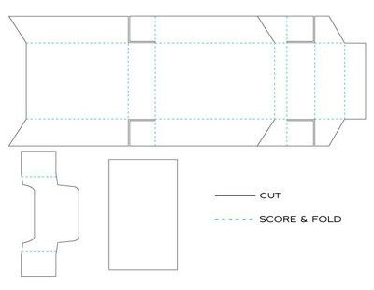

Step 1-3

step 4-6

Step 7 - lip

