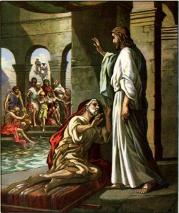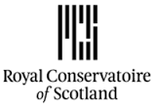

Director: Mark Thomson Lighting Designer: Dylan Hodgson  
Designer: Alisa Kalyanova Sound Designer: Allan Hamilton

The Pool of Bethesda

Settings List

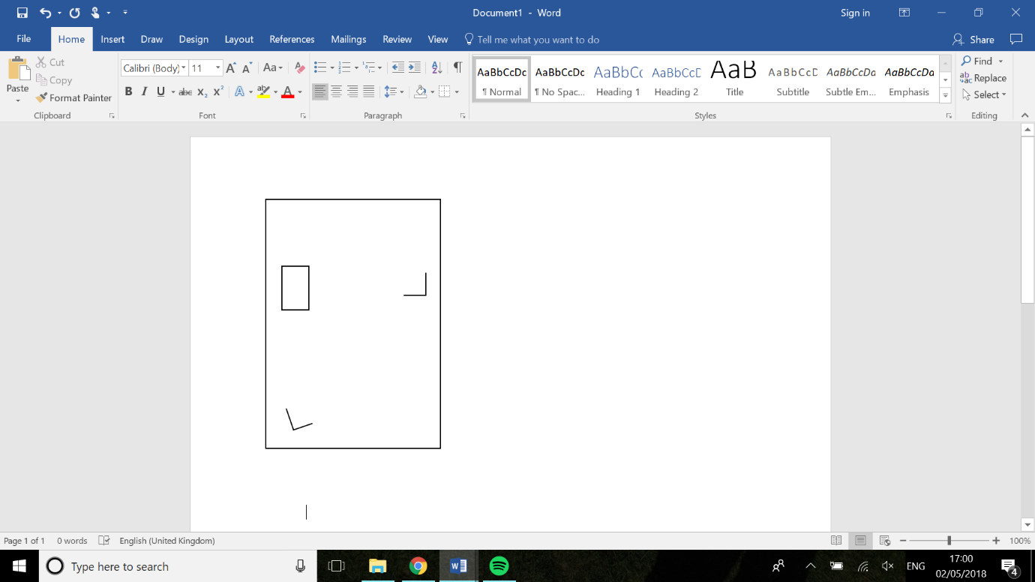**Act 1 pre-set on stage**

US

1. Hogarthian chair DSR (covered by cloth)

2

1. Hogarthian chair CSL (covered by cloth)

3

1. Wooden chest (covered by cloth)

DS

1

(All cloth is to be tucked in to avoid women falling   
  
during dance)

Get well soon cards

8

US

**Act 2 pre-set on stage**

5

4

1

2

3

6

7

1. Hospital bed (With two white pillows,  
   white quilt and blue hospital blanket)

9

Bethesda text

Stacked  
books

1. Blue hospital chair
2. Hospital side table

Bluetooth speaker

1. Circular table
2. Pink chair 1

DS

1. Pink chair 2
2. Pink chair 3
3. Books stacked x3

‘Get well soon’ cards x3

Folded up Bethesda text

Blue Bluetooth speaker

1. Hospital sick bowl (under bed)

**Pre-set in wooden chest**

* Wooden cane with gold handle - Bottom of chest
* Jesus’ robes (pre-set ready to put on) - On top of cane
* Large pillow and old bandages with   
  Figg’s head bandage –On top of Jesus’ robes
* Trepanning set – On top of pillow and bandages
* Wine bottle and two wine glasses – US side of chest

**DS Props Table**

* Hogarth’s sketchbook and leather pouch of charcoals
* Pool of Bethesda paper
* Yellow paper fan
* Blind man’s staff
* Man with gout’s sling
* Contemporary Jane’s bag (two theatre tickets and phone inside)
* Pub glasses with a little bit of drink left in them x3 (two gin glasses and one cider glass)
* Beer coasters x3
* Phone for Contemporary Ruth

**USR Props Table**

* Bouquet of red roses, with one removable rose
* Bouquet of white roses with one removable rose
* Bouquet of wildflowers with one removable flower
* Leather for the patient to bite on
* Black lace fan
* Pink lace fan
* Hogarthian Kate’s fan
* Hairdressing set
* Kate’s clipboard
* Kate’s stethoscope
* Kate’s NHS badge
* Contemporary doctor’s sunglasses x2
* Contemporary doctor’s red noses x2
* Contemporary doctor’s stethoscopes x2
* Contemporary doctor’s NHS lanyards x2
* Simon’s bottles of vodka x4
* Two shot glasses
* Simon’s NHS lanyard
* Simon’s cloth and disinfectant spray
* Wheelchair