Sweet Charity Cast Mic Notes

Yna Tresvalles  She/Her  Charity Hope Valentine | 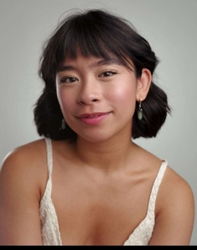
GEN-
- Pink headband, front of head
- Medium Dark Hair
- Pack in right hip for upside down lift in openining scene.

BRASS BAND-
- White brass band hat

POMPEI CLUB-

ROL -

FARNDALE-
- A

Eden Barrie  She/Her  Nicky Pignatelli | 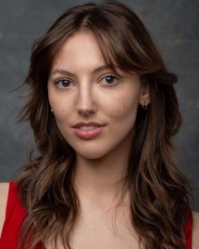
GEN -
- Long Brown Hair

NYC-
- Ponytail with a big bow

BRASS BAND-
- Black and pink brass band hat

POMPEI CLUB-

ROL-

FARNDALE-
- Halter neck orange dress

Matthew Don  He/Him  Marvin / Ensemble | 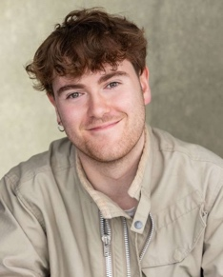
GEN-

NYC -
- Brown fedora(?) on top of head
- Brown flatcap...? Sitting forward on head.

BRASS BAND-
- Black and pink brass band hat

POMPEI CLUB-

ROL-

FARNDALE-

Alice Rose Creasey  She/Her  Suzanne  Dance captain | 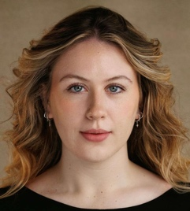
GEN -
- Long blonde hair, dark roots

NYC -
- Sunglasses on front/top of head
- Scarf on head covering hair

BRASS BAND-
- Black and pink brass band hat

POMPEI CLUB-

ROL -

FARNDALE-

Kyle Doney  He/Him  Vittorio Vidal | 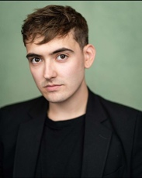
NYC -
- Brown fedora(?) on the front of head
- Four(?) potential hats

BRASS BAND-
- Black and pink brass band hat

POMPEI CLUB-

ROL-

FARNDALE-

Catriona Gauld  She/Her  Helene  Understudy – Charity Valentine | 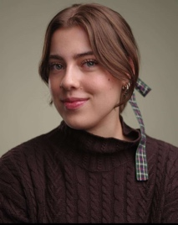
GEN-
- Long Brown Hair

BRASS BAND-
- Black and pink brass band hat

POMPEI CLUB-

ROL-

FARNDALE-
- Red Sparkly Dress (Backless)
- Thick tight red choker necklace

Finlay Mackay  He/Him  Herman | 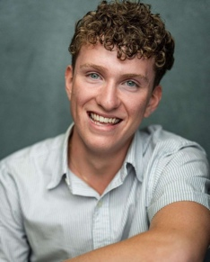
GEN -
- Curly hair
- Particularly short hair at the back, cropped close to the head

NYC -
- Backwards baseball cap on

BRASS BAND-
- Black and pink brass band hat

POMPEI CLUB-

ROL-

FARNDALE-

Gregor McMillan  He/They  Charlie  Understudy – Vittorio & Daddy Brubeck | 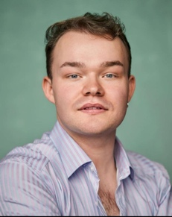
GEN-
- Blonde highlight in hair, silked back
- Length curly at back

NYC-
- Brown fedora(?) at a slightly jaunty angle to one side
- Police Hat in Coney Island

BRASS BAND-
- Black and pink brass band hat

POMPEI CLUB-

ROL-

FARNDALE-
- Yellow halter neck
- Police hat(?)

Camila Lopez Davila  She/Her  Carmen | 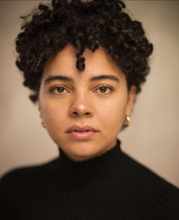
GEN-
- Curly hair will need to be more cautious with head mic placements
- Pink pointy princess hat

BRASS BAND-
- Black and pink brass band hat

POMPEI CLUB-

ROL-

FARNDALE-

Nathan Morris  He/Him  Ensemble | 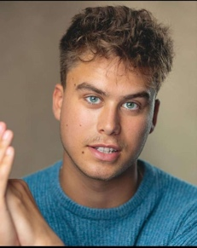
GEN-

NYC-
- Brown fedora/bowler cap coming over the front of the eyes on top of head.

BRASS BAND-
- Black and pink brass band hat

POMPEI CLUB-

ROL-

FARNDALE-
- Police hat

Ava MacKinnon  She/Her  Rosie,  Understudy - Usula March | 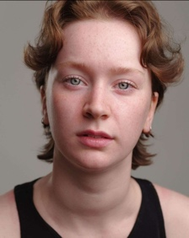
GEN-
- Shorter textured hair

NYC-
- Brown beret sitting on the top of her head

BRASS BAND-
- Blonde wig with black and pink brass band hat on

POMPEI CLUB-

ROL-

FARNDALE-
- Pink Dress (Backless)
- Belt pack or costume may potentially sew a pocket in.
- Wig

Ronan O’Hara  He/They  Daddy Brubeck / Ensemble  Music Captain | 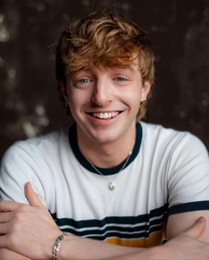
GEN-
- Longer more textured hair

NYC-
- White bakers hat
- Greek fisherman hat with fringe pushed back.
- Big round glasses potentially

BRASS BAND-
- Black and pink brass band hat

POMPEI CLUB-

ROL-
- Headband, maybe will need to move mic lower or bandanna higher.
- Is also shirtless

FARNDALE -
- Short Purple Dress (full back)

Ebba Mård Andersson  She/Her  Frenchy / Elaine  Understudy - Helene | 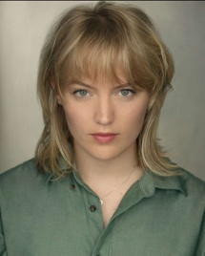
GEN -
- Blonde fringe covers forehead
- Straight medium length hair

NYC-
- Big pearls round neck potentially

BRASS BAND-
- Black and pink brass band hat

POMPEI CLUB-

ROL-

FARNDALE -
- Red Tube top and headband
- Mic pocket in tube top
- Thick red choker(?) tie(?)

George Shuter  He/Him  Oscar Lindquist | 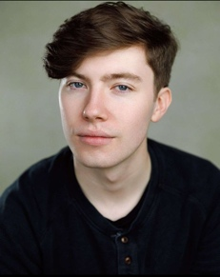
GEN-

NYC-
- Brown fedora(?) slightly on one side of the head rather than top

BRASS BAND-
- Not(?) in this number

POMEPEI CLUB-

ROL-
- Jaunty brown fedora on head
- Fringe pushed back under hat

FARNDALE-

Alexander (Alex) Suguitan  He/Him  Ensemble  Understudy Oscar Lindquist | 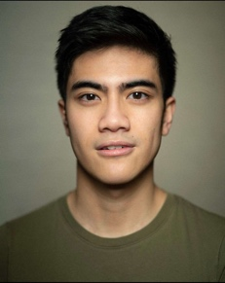
GEN -

NYC -
- Buente Cap slightly angled upwards.

BRASS BAND-
- Black and pink brass band hat

POMPEI CLUB-

ROL-

FARNDALE-

Mackenzie Wilcox  She/Her  Ursula March  Understudy Nikki | 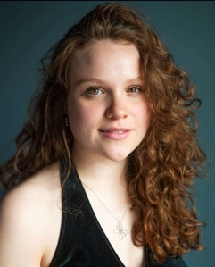
GEN -
- Curly hair, medium, brown

NYC -
- Brown hat(?) with black elastic straps coming down.

BRASS BAND-
- Black and pink brass band hat

POMPEI CLUB-
- Backless sparkly dress, need to re tape mic cable
- Mic pack on bra
- Brown shorter wig
- Potential volume on wig for fringe placement

ROL-

FARNDALE-

,
Notes -
- Ronan, Matthew, George, Alex, Gregor, Nathan, Findlay, Kyle all switch headwear and will have 1-2 differing hats, to define different NYC characters.
- Coney Island number requires hats/headwear being secure to the head.
- Nathan and Kyle don't wear hats in the coney island number.
- Mic Belts under blacks
- Ensure packs are properly secured for difficult lifts

Questions-
- Bouffant hair style may be difficult to mic. Who has their hair up and who remains with it down.
- Cat hair up or down?
- Will Gregors hair remained slicked back, and will the blonde bit stay? A - Yes
- Will any of the guys be getting haircuts before the show and if so how short will they be?
- Ava fandago dress mic placement? A – Costume to look at

TAP SHOES
- YNA MAY POTENTIALLY NEED HER TAP SHOES MICED
- Everyone has tap shoes on for BRASS BAND number
- George is not involved in brass band

